Example
Default.aspx Page
<%@ Page Language="C#" AutoEventWireup="true" CodeFile="Default.aspx.cs" Inherits="_Default" %>
<!DOCTYPE html PUBLIC "-//W3C//DTD XHTML 1.0 Transitional//EN" "http://www.w3.org/TR/xhtml1/DTD/xhtml1-transitional.dtd">
<html xmlns="http://www.w3.org/1999/xhtml">
<head runat="server">
<title></title>
</head>
<body>
<form id="form1" runat="server">
<div style="width: 414px; background-color: #E6E6FA; height: 110px;">
Name&nbsp;
<asp:textbox id="TextBox1" runat="server" style="z-index: 1; left: 73px; top: 15px;
position: absolute">
</asp:textbox>
<asp:requiredfieldvalidator id="RequiredFieldValidator1" runat="server" controltovalidate="TextBox1"
errormessage="Cannot be Blank" setfocusonerror="True" style="position: absolute;
z-index: 1; left: 238px; top: 21px">
</asp:requiredfieldvalidator>
<br />
Mobile
<asp:textbox id="TextBox2" runat="server" style="position: relative; top: 4px; left: 12px">
</asp:textbox>
<br />
<tr>
<td class="style3">
Email
</td>
<td class="style2">
<asp:regularexpressionvalidator id="remail" runat="server" controltovalidate="txtemail"
errormessage="Enter in proper format" validationexpression="\w+([-+.']\w+)*@\w+([-.]\w+)*\.\w+([-.]\w+)*"
style="z-index: 1; left: 279px; top: 61px; position: absolute">
</asp:regularexpressionvalidator>
<asp:textbox id="txtemail" runat="server" width="200px" style="z-index: 1; left: 73px;
top: 62px; position: absolute">
</asp:textbox>
</td>
<td>
</td>
</tr>
<asp:button id="Button1" runat="server" text="SUBMIT" style="z-index: 1; left: 73px;
top: 91px; position: absolute; right: 1066px" />
<br />
<br />
</div>
</form>
</body>
</html>
Output
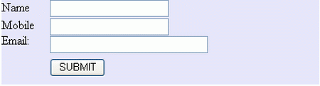
If any input field is left blank then it is handle by the control name as RequiredField Validation control.
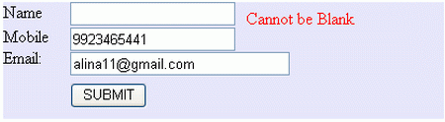
It ensures that the value of an input control matches a specified pattern and this is handled by the RegularExpression Validation control.
